Group: 1

Design Document

Back End Rapid Prototype



**Overall Structure**

The backend architecture was designed in two parts, one named BackEnd does verification and management of the files ensuring realiability. The MakeNewFiles file creates the files from the backend of the system, generating the necessary logs that would be created upon various actions of account creation and ticket barter.

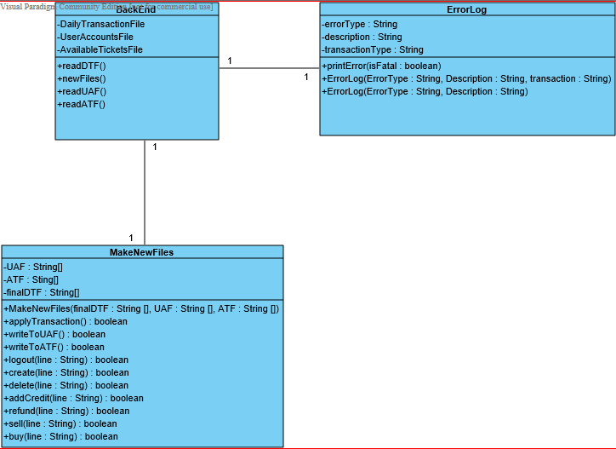

**BackEnd.java**

|  |  |
| --- | --- |
| public static void newFiles | Initiated following the error checking, it invokes a new file. |
| public static boolean readDTF | Handles the reading for the Daily Transaction File, multiple DTF’s are read sequentially. |
| public static boolean readATF | This method deals with reading the Available Tickets File. |

**MakeNewFiles.java**

|  |  |
| --- | --- |
| public static boolean applyTransactions | Method for applying transactions to the Daily Transaction File |
| public static boolean writeToUAF | Log new data into UAF |
| public static boolean writeToATF | Log new data into ATF |
| public static boolean logout | Handles the logout function, making sure to log all logouts, terminating the accessibility of user. |
| public static boolean create | Creates accounts when a new username is registered. |
| public static boolean delete | Parses the file to find the user, to delete the specific user. |
| public static boolean addCredit | Method handles the checking and ability to addCredit to specific users. |
| public static boolean refund | Refund operation is lengthy in that it locates seller and buyer and performs refund. |
| public static boolean sell | Handles the sales of tickets with accordance to event. |
| public static boolean buy | The purchase of tickets is done by invoking the above method. |

**ErrorLog.java**

|  |  |
| --- | --- |
| public ErrorLog | Same Method initiated twice, handles different error types |
| public static void printError | Prints the error to console |
|  |  |